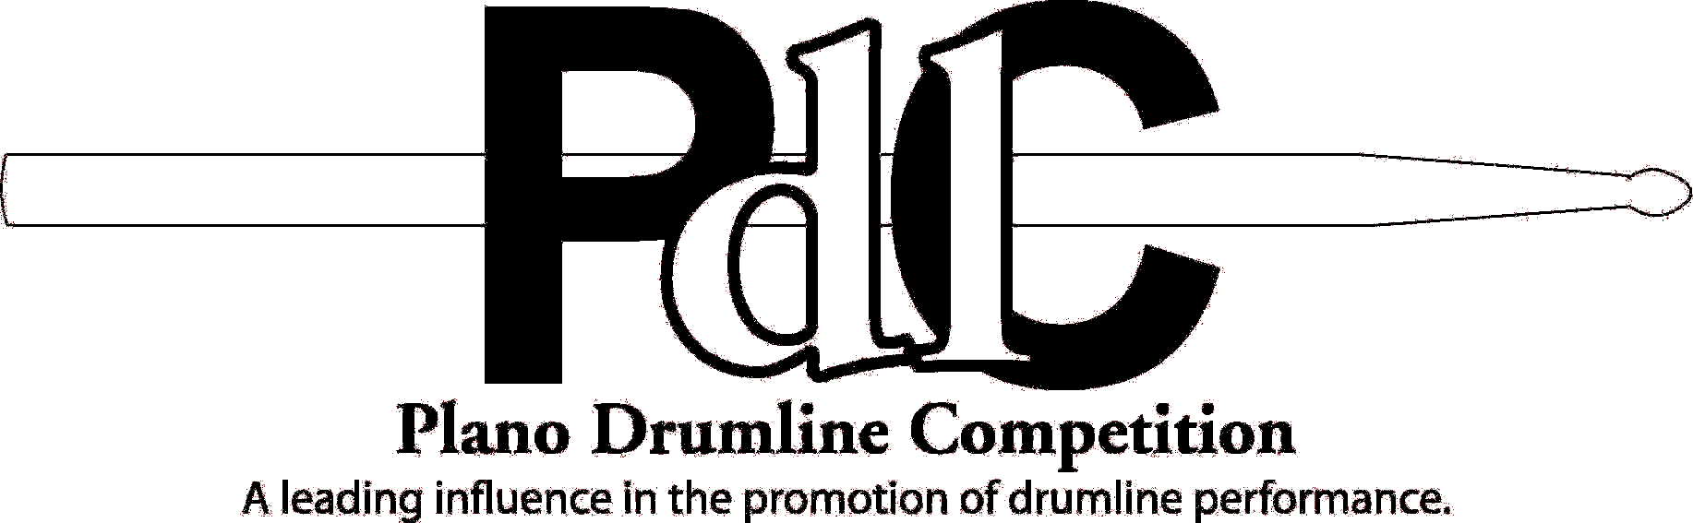
 |  | Performance Video |  |  |  | Performance Video
«High_School_Drumline»  «DL_Category»  September 27th, 2008 |  |  |  | «High_School_Drumline»  «DL_Category»  September 27th, 2008
 |  | Performance Video |  |  |  | Performance Video
«High_School_Drumline»  «DL_Category»  September 27th, 2008 |  |  |  | «High_School_Drumline»  «DL_Category»  September 27th, 2008
 |  | Performance Video |  |  |  | Performance Video
«High_School_Drumline»  «DL_Category»  September 27th, 2008 |  |  |  | «High_School_Drumline»  «DL_Category»  September 27th, 2008

